(Approx. 416 words)

Add a Caption to a Picture in Word
By Nancy DeMarte, Vice President, Sarasota Technology Users Group
The STUG Monitor
www.thestug.org
vp1 (at) the stug.org

Any Word document can be enhanced by a picture. To clarify what the picture represents, like its name or location, you can include text in the form of a caption. Word makes it easy to add a caption. Here is how it’s done:

Open Word. Add a picture from your Pictures folder by clicking the Insert tab > Pictures. This opens your Picture Gallery. Click a picture > Insert. The picture will appear in your document, but often it is too large. To change its size, click in any corner of the picture and drag your mouse diagonally toward the center until it is your desired size.

You can also move the picture to a different place in your document, but not until you change the layout option. Click the picture and then the Layout Options icon (shown at right). Next click the top left option called Square. Then drag the picture where you want it to be in the document. This icon also allows text to wrap around the picture.

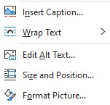
To add a caption, right click the picture and select “Insert Caption” from the dropdown menu. Figure 1 will be in the caption box if this is the first picture in your document. You won’t be able to get rid of the text Figure 1 until you have entered your caption text. Type your caption in the Caption box and click OK to make your caption appear below the picture.

Now you can click after Figure 1 and backspace to remove it, leaving only your text. Using the Home tab, you can then remove the italics, center the caption, or change the font and size.
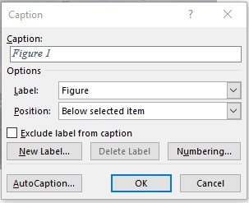
This is a Caption

To be sure that your caption remains with its picture, “group” the two together. First click the picture to select it. Small “handles” will surround it. Then hold down the Shift key and click the caption so that both are selected. As soon as you have done that, you will see a new tab on the command ribbon at the top of the screen. It may say Shape Format or Picture Format. Click either one. Next, toward the right end of the ribbon, you will see an icon called Group. Click Group, then Group again, and your picture and caption will become one box, ready to move anywhere on the page.

